MODULE 1 — STUDENT STUDY NOTES
Internet of Things & Applications | PEMRT525
KTU | S5 | MR 2K24 | JECC | Source: Bahga & Madisetti — IoT: A Hands-On Approach, Ch.1

# | Topic | Hours
1 | Introduction to IoT — Definitions & Characteristics | Hour 1
2 | Physical Design of IoT — Things & Protocol Stack | Hours 2–3
3 | Logical Design — Functional Blocks | Hour 3
4 | IoT Communication Models & APIs | Hour 4
5 | IoT Enabling Technologies | Hour 5
6 | IoT Levels & Deployment Templates | Hours 6–7

How to use: Read each topic in full sentences — understand the idea, look at the figure, then cover and recall. Use the coloured boxes to revise fast before the exam.

TOPIC 1: Introduction to IoT — Definitions & Characteristics (Hour 1)

The Internet of Things, commonly known as IoT, is one of the most transformative technologies of the 21st century. Imagine your refrigerator sending you a notification when you run out of milk, your air conditioner automatically cooling the room before you arrive home, or your doctor monitoring your heart rate from a remote clinic — all of this is made possible by IoT. At its core, IoT is about connecting physical objects to the Internet so they can sense, communicate, and act intelligently.
📖 DEFINITION: IoT — A dynamic global network infrastructure with self-configuring capabilities based on standard and interoperable communication protocols, where physical and virtual "things" have identities and are seamlessly integrated into the information network.
The key idea behind IoT can be summarised in three words: Things, Internet, and Intelligence. IoT devices collect real-world data through sensors, transmit it over the Internet, and use that information to perform useful actions — either automatically or with human intervention.
⭐ KEY POINT: IoT = Things + Internet + Intelligence. Any physical object that can sense, communicate, and act through the Internet is an IoT device.
1.1 IoT Application Domains

IoT has found applications in almost every sector of human life. In home automation, smart lights, air conditioners, and security cameras can be remotely controlled and programmed. Smart cities use IoT for intelligent traffic management, smart parking systems, waste collection, and public safety monitoring. In the environment domain, IoT sensors monitor air quality, forest fire risk, and water contamination. The energy sector uses IoT-enabled smart grids and smart meters to optimise power consumption. Retail stores use IoT for smart shelves and inventory tracking, while logistics companies track packages and vehicles in real time. Precision agriculture benefits from IoT through automated irrigation and soil moisture monitoring. Industrial plants use IoT for predictive maintenance and process automation. Healthcare systems monitor patients remotely, and transportation networks rely on IoT for collision avoidance and connected vehicles.
1.2 Characteristics of IoT

IoT systems have five defining characteristics that distinguish them from ordinary networked systems. Understanding these characteristics helps you identify whether a system truly qualifies as an IoT system.
The first characteristic is Dynamic and Self-Adapting behaviour. IoT devices can automatically change their operation based on the surrounding context. A surveillance camera, for example, switches to infrared night vision when it detects low light conditions and increases its resolution when it detects motion — all without any human intervention.
The second characteristic is Self-Configuring capability. IoT devices can configure themselves, set up their network connections, and download software updates without manual setup. When 500 weather sensor nodes are deployed across a region, they arrange themselves into a working network automatically, saving enormous time and cost.
The third characteristic is support for Interoperable Communication Protocols. IoT devices must be able to talk to different types of devices using multiple standard protocols. A single smart home device might communicate with a router using WiFi, with a sensor using Bluetooth Low Energy, and with a cloud server using MQTT — all at the same time.
The fourth characteristic is Unique Identity. Every IoT device in the world has a unique identifier — either an IP address or a URI — so it can be individually addressed and communicated with. This is why the transition from IPv4 to IPv6 is critical for IoT; IPv6 provides enough address space to assign a unique address to every device on Earth.
The fifth characteristic is that IoT devices are Integrated into the Information Network. They can describe themselves, be discovered by other devices, and continuously share data with the broader network. A weather node, for instance, broadcasts its temperature-sensing capability so that other devices and management systems can find and use it.
🧠 TRICK: 5 characteristics — Mnemonic: DSIUI — Dynamic, Self-configuring, Interoperable protocols, Unique identity, Integrated into network.
📝 EXAM TIP: "Define IoT and explain its characteristics" — write the definition + explain all 5 characteristics with one real-world example each. This is a standard 9-mark question.

TOPIC 2: Physical Design of IoT — Things & Protocol Stack (Hours 2–3)

The physical design of an IoT system refers to the actual hardware components that make up the system — the devices themselves and the communication protocols they use to exchange data. In essence, physical design answers the question: "What are the real, tangible parts of an IoT system?"
2.1 Things in IoT — IoT Devices

📖 DEFINITION: IoT Device — A physical object equipped with sensors, a processor, communication hardware, and sometimes actuators, that can sense real-world data, process or transmit it, and perform physical actions in response.
An IoT device follows a four-step operational cycle: it Senses data from the physical world using sensors such as temperature, pressure, or motion detectors; it Processes that data either locally or by sending it to a cloud server; it Communicates the processed results using wireless or wired protocols; and it Actuates by triggering physical outputs such as opening a valve, turning on a light, or sending an alert. Common IoT platforms include the Raspberry Pi, Arduino, NodeMCU, and ESP32.
IoT devices connect to the outside world through several types of interfaces. Wired network interfaces such as Ethernet (RJ45) provide reliable, high-speed Internet connections. Wireless interfaces such as WiFi, ZigBee, and Bluetooth allow devices to communicate without cables. Memory interfaces such as SD card slots and flash storage allow devices to store data locally. I/O interfaces for sensors and actuators — including UART, SPI, I2C, and CAN — allow the device to communicate with the physical components it controls. Audio/Video interfaces such as HDMI and camera ports enable multimedia capture and display.
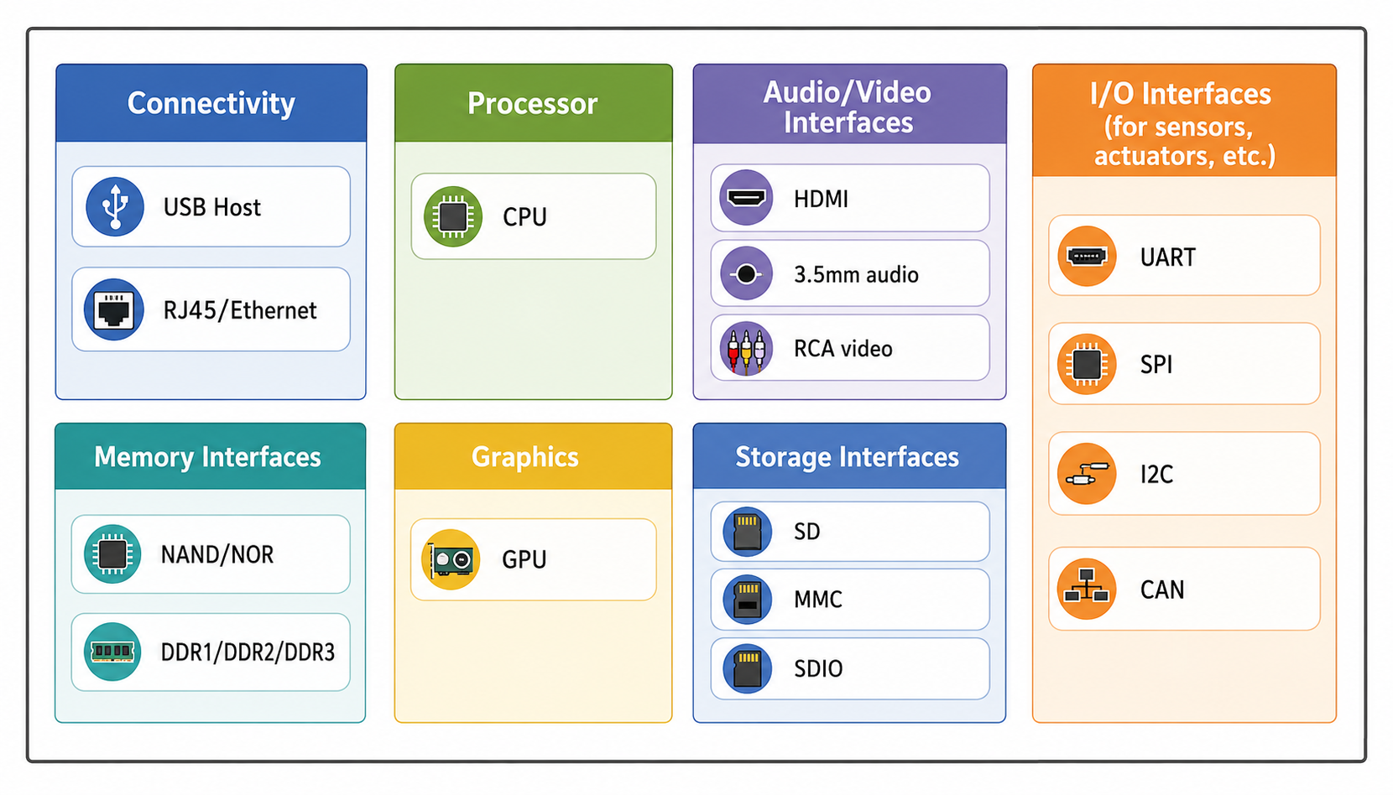
Figure 1.3: Generic Block Diagram of an IoT Device

IoT devices come in many forms. They include wearable health sensors, smart watches, LED lighting systems, connected automobiles, industrial machines, and household appliances. The figure below shows the wide variety of real-world devices that can be classified as IoT devices.
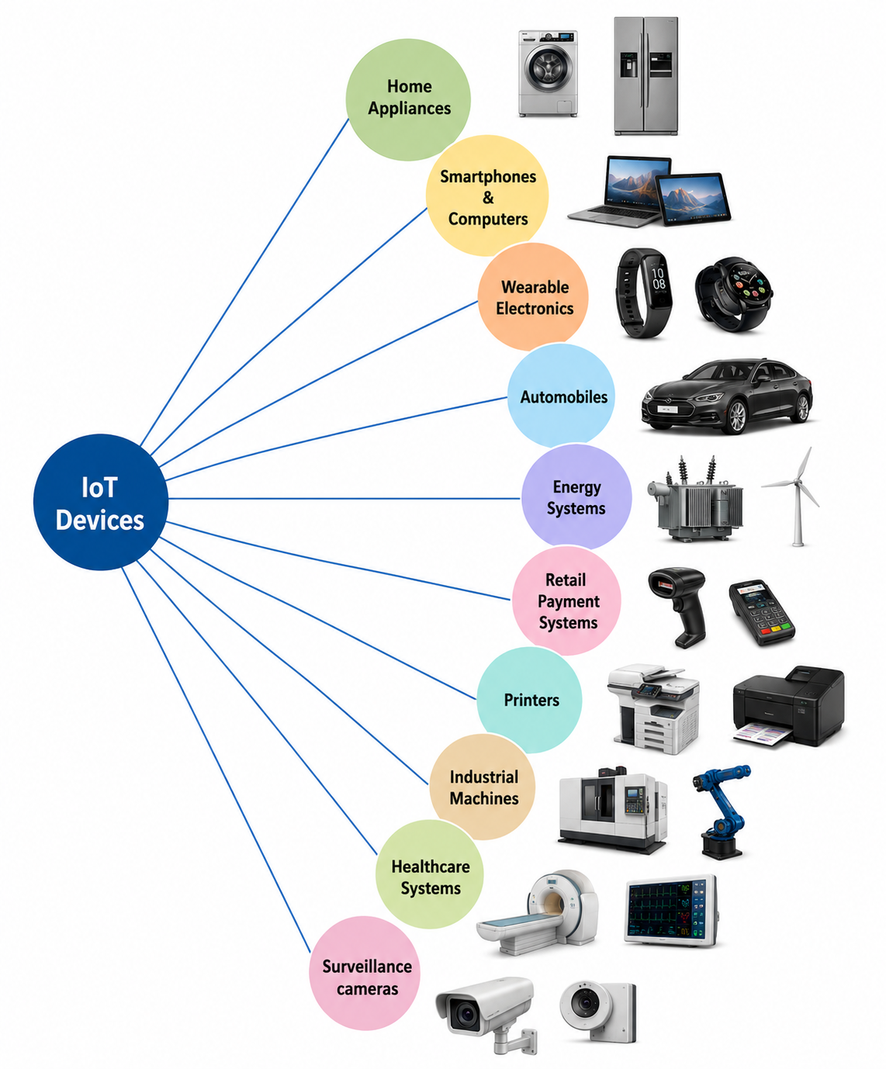
Figure 1.4: Examples of IoT Devices

2.2 IoT Protocol Stack — Four Layers

Just as computers use the TCP/IP model to communicate over the Internet, IoT systems use a four-layer protocol stack to enable communication between devices, networks, and applications. Each layer is responsible for a specific aspect of communication, and protocols at one layer rely on the services provided by the layer below it.
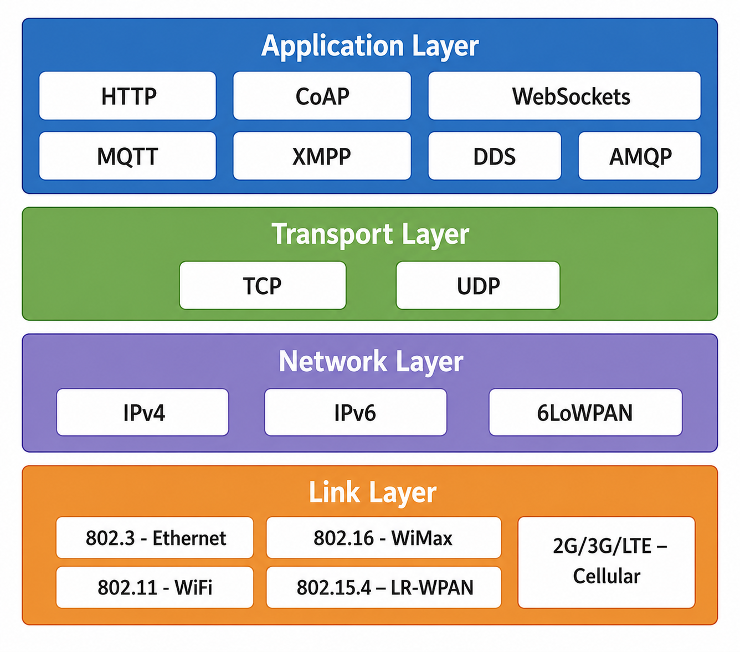
Figure 1.5: IoT Protocol Stack organised by Layer

▶ Link Layer — Physical Communication

The Link Layer, also known as the Physical Layer, handles the actual transmission of signals between devices that are directly connected. IEEE 802.3 Ethernet provides wired connections at speeds from 10 Mb/s to over 40 Gb/s using CSMA/CD collision detection. IEEE 802.11 WiFi is the most widely used wireless protocol for home and office IoT devices, supporting speeds up to 1 Gb/s and beyond. IEEE 802.15.4, the standard used by ZigBee and LR-WPAN, is specifically designed for low-power, low-cost wireless sensor networks and operates at 250 Kb/s over ranges of 10 to 100 metres — making it ideal for the backbone of WSNs. IEEE 802.16 WiMax provides wireless broadband over kilometre-scale distances, while 2G/3G/4G LTE cellular networks connect outdoor and mobile IoT devices.
Protocol | Standard | Data Rate | Best Used For
Ethernet | IEEE 802.3 | 10 Mb/s – 40 Gb/s | Wired, reliable IoT gateways
WiFi | IEEE 802.11 | Up to 1 Gb/s+ | Home and office IoT devices
WiMax | IEEE 802.16 | 1.5 Mb/s – 1 Gb/s | Outdoor, long-range coverage
ZigBee/LR-WPAN | IEEE 802.15.4 | 250 Kb/s (10–100 m) | WSN sensor nodes — low power
LTE/4G | 3GPP | Mb/s range | Mobile, outdoor IoT deployments

▶ Network Layer — Addressing and Routing

The Network Layer is responsible for assigning unique addresses to every device and routing data packets from source to destination across multiple networks. IPv4 uses a 32-bit address, which allows approximately 4.3 billion unique addresses — a number that has already been exhausted given the explosion of Internet-connected devices worldwide. IPv6 solves this problem by using 128-bit addresses, providing 3.4 × 10³⁸ possible addresses, which is effectively unlimited and is essential for a world with billions of IoT devices. 6LoWPAN (IPv6 over Low-Power Wireless Personal Area Networks) is a special adaptation layer that makes it possible to run IPv6 on resource-constrained 802.15.4 sensor nodes by compressing the normally 40-byte IPv6 header to as few as 2 bytes, making every tiny sensor node directly addressable on the Internet.
🔔 REMEMBER: IPv4 = 32-bit = ~4 billion addresses (EXHAUSTED). IPv6 = 128-bit = 3.4×10³⁸ addresses (unlimited). 6LoWPAN = IPv6 compression for tiny IoT sensors on 802.15.4 networks.
▶ Transport Layer — End-to-End Delivery

The Transport Layer provides end-to-end communication between applications running on two devices. TCP (Transmission Control Protocol) is a connection-oriented protocol that guarantees reliable, ordered packet delivery — it ensures every packet arrives and that packets are reassembled in the correct order. This reliability comes at the cost of additional overhead, making TCP suitable for applications like MQTT messaging and HTTP web requests where data integrity matters. UDP (User Datagram Protocol) is a connectionless, lightweight protocol that sends packets without waiting for acknowledgement. Although it does not guarantee delivery or order, its low overhead makes it perfect for real-time IoT applications like live sensor data streaming and video feeds where occasional packet loss is acceptable but speed is critical.
Feature | TCP | UDP
Type | Connection-oriented | Connectionless
Reliability | Guaranteed delivery | No guarantee
Speed | Slower (setup overhead) | Faster (no setup)
Used by | MQTT, HTTP, WebSocket | CoAP, real-time streams
IoT use | Reliable sensor commands | Live video, voice, telemetry

▶ Application Layer — IoT Protocols

The Application Layer defines the high-level communication protocols that applications use to exchange structured data. HTTP (Hypertext Transfer Protocol) is the foundation of the World Wide Web, supporting GET, POST, PUT, and DELETE commands, but its high overhead makes it less suitable for resource-constrained IoT devices. CoAP (Constrained Application Protocol) is a lightweight version of HTTP designed specifically for low-power IoT devices; it runs over UDP rather than TCP to minimise overhead. MQTT (Message Queuing Telemetry Transport) is a lightweight publish-subscribe protocol over TCP that has become the most popular IoT messaging protocol due to its simplicity and very low bandwidth requirements. WebSocket provides a persistent, full-duplex TCP connection where both client and server can send messages at any time — making it ideal for real-time dashboards. XMPP uses XML-based messaging for presence detection and real-time communication. DDS (Data Distribution Service) is a publish-subscribe middleware with Quality-of-Service support widely used in industrial IoT. AMQP (Advanced Message Queuing Protocol) supports both point-to-point and publish-subscribe patterns and is commonly used in enterprise messaging systems.
⭐ KEY POINT: MQTT is the most popular IoT protocol. It is lightweight, uses publish-subscribe, runs over TCP, and is used in everything from home automation to industrial monitoring. Think of it as WhatsApp for IoT devices.
🧠 TRICK: Application protocols: HTTP, CoAP, MQTT, WebSocket, XMPP, DDS, AMQP — "Huge Crowds Meet Web, eXchanging Data And Messages Profusely"
📝 EXAM TIP: "Explain the IoT protocol stack" — guaranteed 9-mark question. Draw the 4-layer diagram, name the protocols at each layer, and explain at least one protocol per layer with its key property.

TOPIC 3: Logical Design of IoT — Functional Blocks (Hour 3)

📖 DEFINITION: Logical Design — An abstract representation of an IoT system that describes what the system does and how the components interact, without specifying the physical hardware or implementation details.
While physical design deals with actual hardware, logical design describes the overall architecture and functional organisation of an IoT system. Bahga and Madisetti define six functional blocks that every complete IoT system must contain. These blocks work together as an integrated whole, with each block handling a specific responsibility.
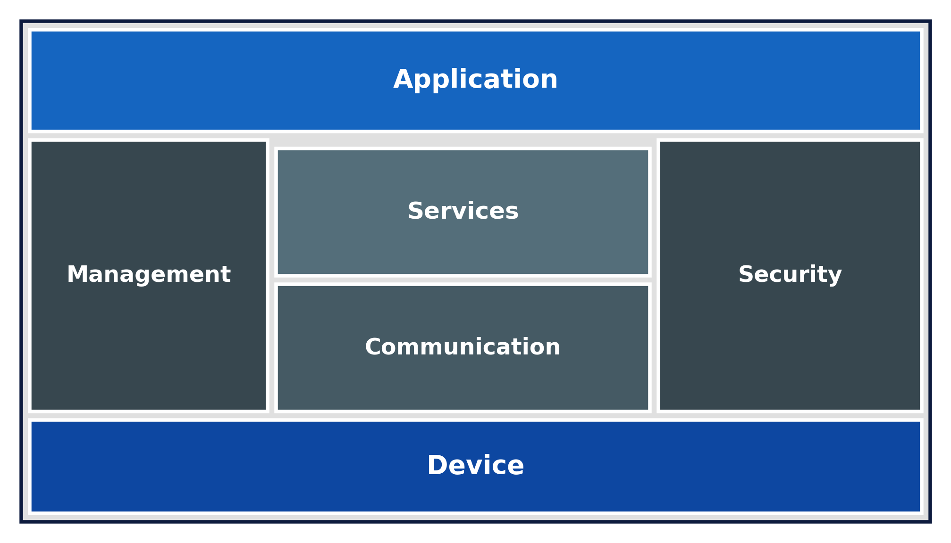
Figure 1.6: Functional Blocks of an IoT System

The Six Functional Blocks

The Device block is the foundation of any IoT system. It provides two core capabilities: sensing, which involves collecting real-world data through sensors such as temperature probes, accelerometers, cameras, and gas detectors; and actuation, which involves controlling physical outputs such as motors, valves, displays, and alarms. The Device block interacts directly with the physical world and is the starting point of all IoT data flows.
The Communication block is responsible for managing all data transfer within the IoT system. It implements the various communication protocols discussed in Topic 2 — including MQTT, HTTP, CoAP, and WebSocket — and handles the movement of data between devices, cloud services, and user applications. Without a robust communication block, no data could flow between the other components.
The Services block provides four essential services that sit above raw communication. Device Monitoring continuously tracks the operational status and health of all connected devices. Device Control sends commands back to devices to change their behaviour or trigger actions. Data Publishing pushes sensor data to subscribers who need it. Device Discovery allows the system to automatically detect and register newly added devices without manual configuration.
The Management block governs the entire IoT system from an operational standpoint. It handles device provisioning and configuration when new devices are added, manages over-the-air (OTA) firmware updates so devices can be updated remotely, monitors system-wide performance, and handles fault detection and recovery. The management block is essentially the administrative brain of the system.
The Security block is unique because it is a cross-cutting concern — unlike the other five blocks, security is not a standalone component but a set of capabilities that must be applied to every other block simultaneously. It provides authentication to verify the identity of devices and users, authorisation to control what actions they are permitted to perform, data integrity mechanisms to prevent data from being tampered with in transit, and encryption to protect stored and transmitted data from unauthorised access.
The Application block is the user-facing interface of the IoT system. It presents data through dashboards, charts, and graphs so that users can visualise sensor readings, monitor device status, and issue control commands. Applications might be mobile apps for home automation, industrial control panels for factory monitoring, or web dashboards for city-wide smart systems.
🔔 REMEMBER: Security WRAPS all other blocks — it applies simultaneously to Device, Communication, Services, Management, and Application. It is the only block with no single dedicated position because it must be everywhere.
⭐ KEY POINT: The 6 blocks: Device → Communication → Services → Management → Security (cross-cutting) → Application. Mnemonic: "Does Clever Systems Make Security Applications"
📝 EXAM TIP: "Explain the functional blocks of an IoT system" — list all 6, explain the role of each in sentences, and clearly state that Security is a cross-cutting concern. This appears in both 3-mark and 9-mark questions.

TOPIC 4: IoT Communication Models & APIs (Hour 4)

IoT devices do not communicate in just one way. Depending on the application requirements — whether real-time, high-volume, or persistent — different communication patterns are used. Bahga and Madisetti describe four fundamental IoT communication models, each suited to different scenarios.
4.1 Request-Response Model

The Request-Response model is the simplest and most familiar communication pattern — it works exactly like asking a question and receiving an answer. In this model, a client device sends a request to a server, the server processes that request by accessing its resources, prepares an appropriate response, and sends it back to the client. Each request-response pair is completely independent of all previous interactions, which means the server does not store any information about past requests between interactions. This property is called statelessness. HTTP and CoAP are the primary protocols that implement the request-response model. A typical example is a mobile app sending a GET request to a weather IoT server asking for the current temperature, and the server responding with "32°C" — after which the server forgets the interaction entirely.
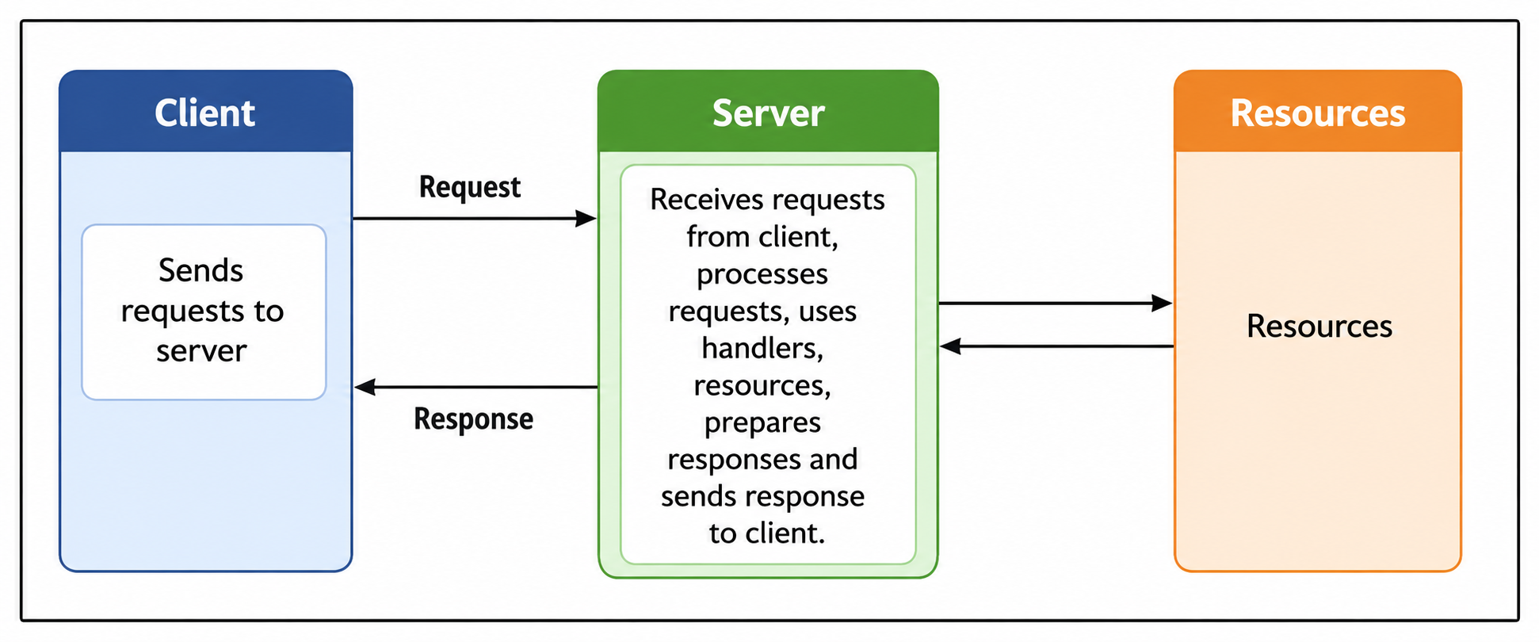
Figure 1.7: Request-Response Communication Model

⭐ KEY POINT: Request-Response is STATELESS — the server has no memory of previous requests. Every request must carry all the information the server needs to respond.
4.2 Publish-Subscribe Model

The Publish-Subscribe model introduces a third party called a broker that completely decouples data producers from data consumers. Publishers — such as IoT sensors — send data messages to named channels called topics on the broker, without knowing anything about who will receive the data. Subscribers — such as monitoring dashboards or other devices — register their interest in specific topics with the broker, and automatically receive messages published to those topics. The broker's job is to receive all published messages and efficiently route each one to all interested subscribers. This decoupling is extremely powerful in IoT systems because sensors can publish data continuously without caring whether anyone is currently listening, and new subscribers can be added at any time without modifying the publishers. MQTT, AMQP, and DDS all implement the publish-subscribe pattern. For example, a temperature sensor publishes to the topic "/home/livingroom/temp" and both a mobile app and a smart thermostat subscribe to that topic — both receive the temperature updates automatically.
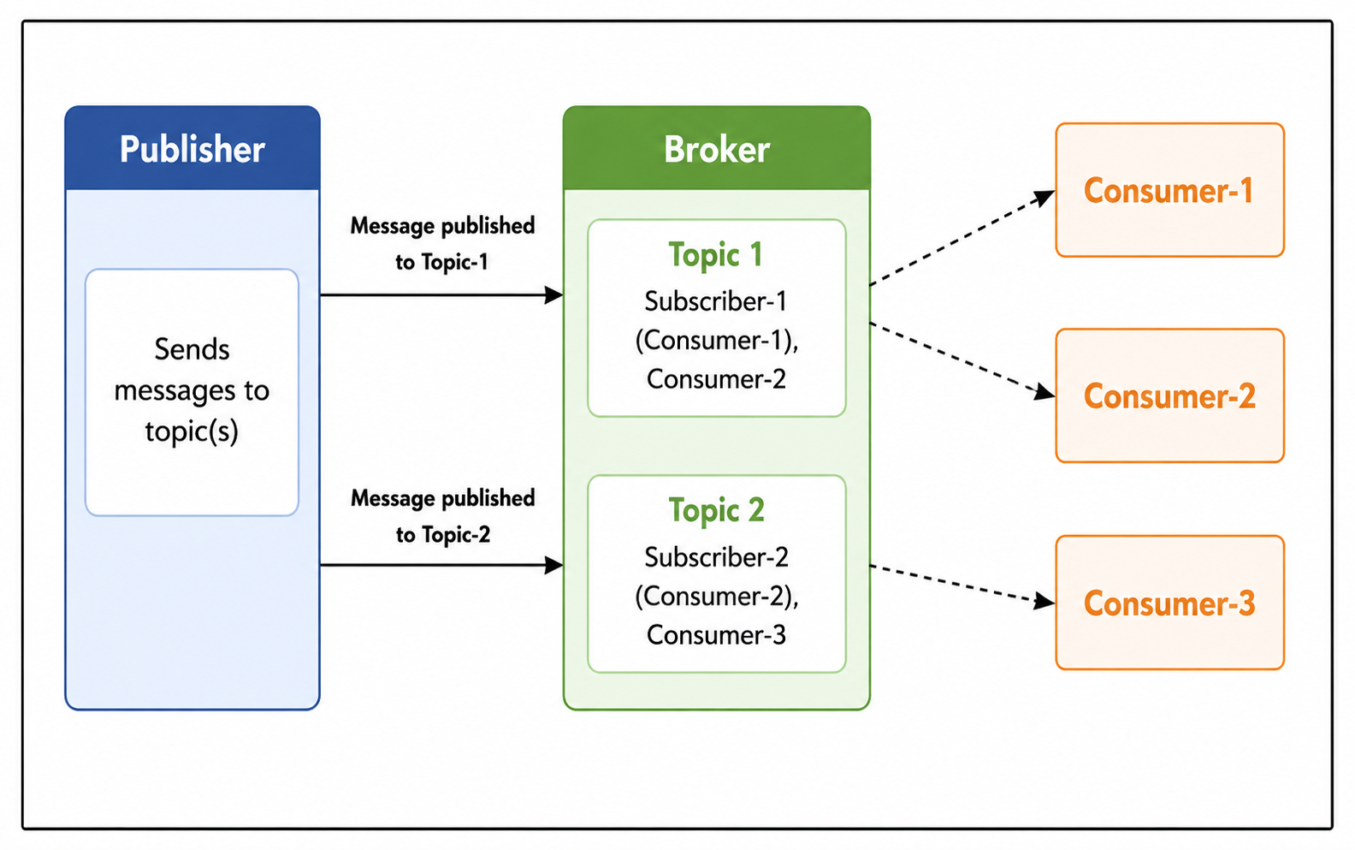
Figure 1.8: Publish-Subscribe Communication Model

⭐ KEY POINT: Publish-Subscribe DECOUPLES producers from consumers through a broker. Publishers and subscribers do not need to know each other, and can operate completely independently.
4.3 Push-Pull Model

The Push-Pull model, also known as the Pipeline model, introduces message queues as buffers between producers and consumers. Producers push data messages into queues, and consumers pull messages from queues at their own pace. The key advantage of this model is that queues act as temporary storage buffers, absorbing speed mismatches between producers and consumers. If a temperature sensor generates readings every second but the analytics system can only process ten readings per minute, the queue holds the excess readings until the consumer is ready — preventing any data loss. Producers and consumers are completely independent and can operate at different rates without coordination. ZeroMQ and Apache Kafka are popular frameworks that implement this model. A practical example would be a fleet of industrial sensors pushing machine data into queues, while a batch analytics engine pulls and processes the data at its own pace overnight.
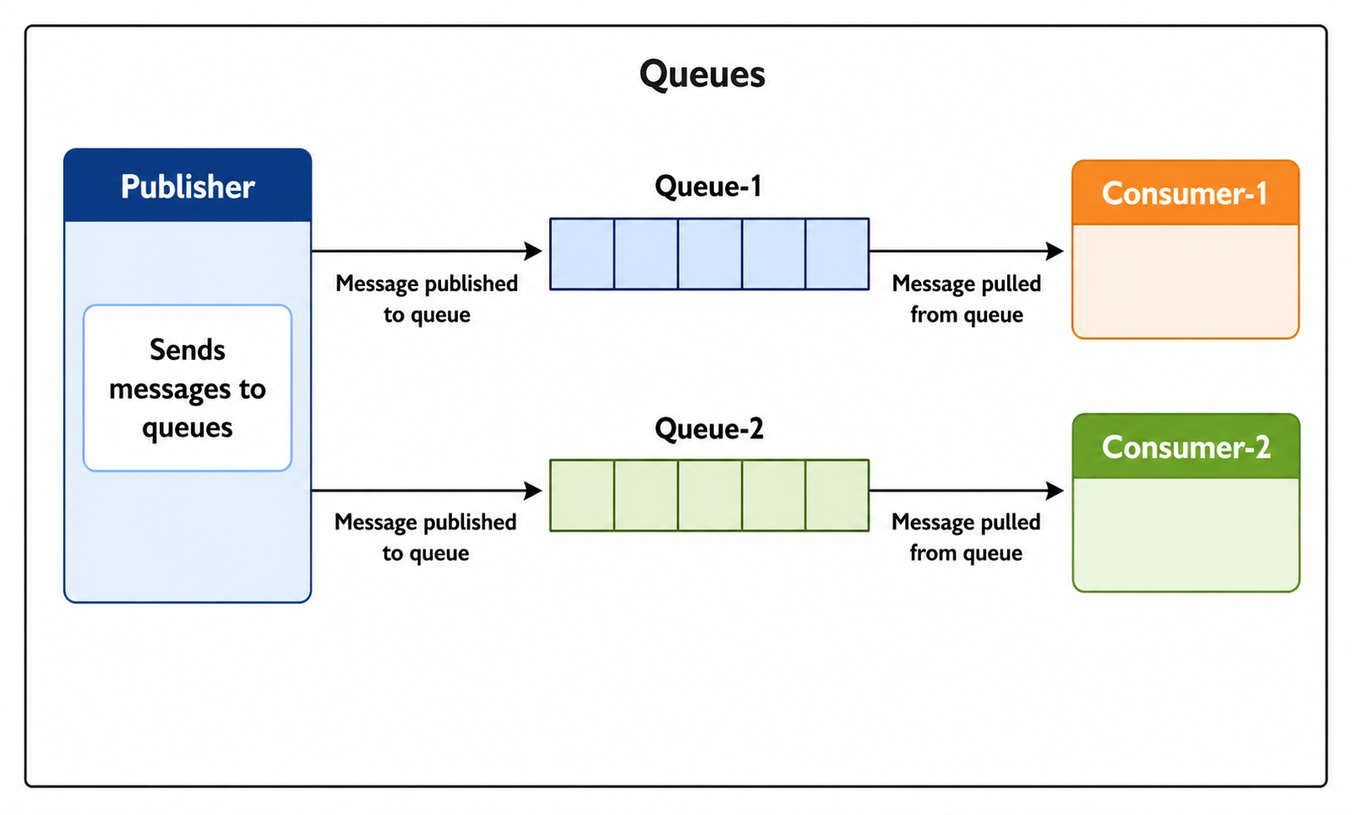
Figure 1.9: Push-Pull Communication Model

⭐ KEY POINT: Push-Pull is ideal when producers and consumers work at DIFFERENT SPEEDS. Queues prevent data loss by acting as buffers between them.
4.4 Exclusive Pair Model

The Exclusive Pair model is the most direct form of IoT communication — it establishes a persistent, dedicated, full-duplex connection between exactly two parties: a client and a server. The client initiates the connection by sending a setup request to the server, which accepts it. Once established, the connection stays open indefinitely, allowing both parties to send messages to each other at any time without waiting for a request. The server keeps track of all open connections, making this a stateful communication model. The connection only ends when the client explicitly sends a close request. WebSocket is the primary protocol implementing this model. An industrial monitoring dashboard that maintains a live WebSocket connection to a factory server — receiving machine status updates every second and sending control commands in the other direction — is a classic example of the exclusive pair model.
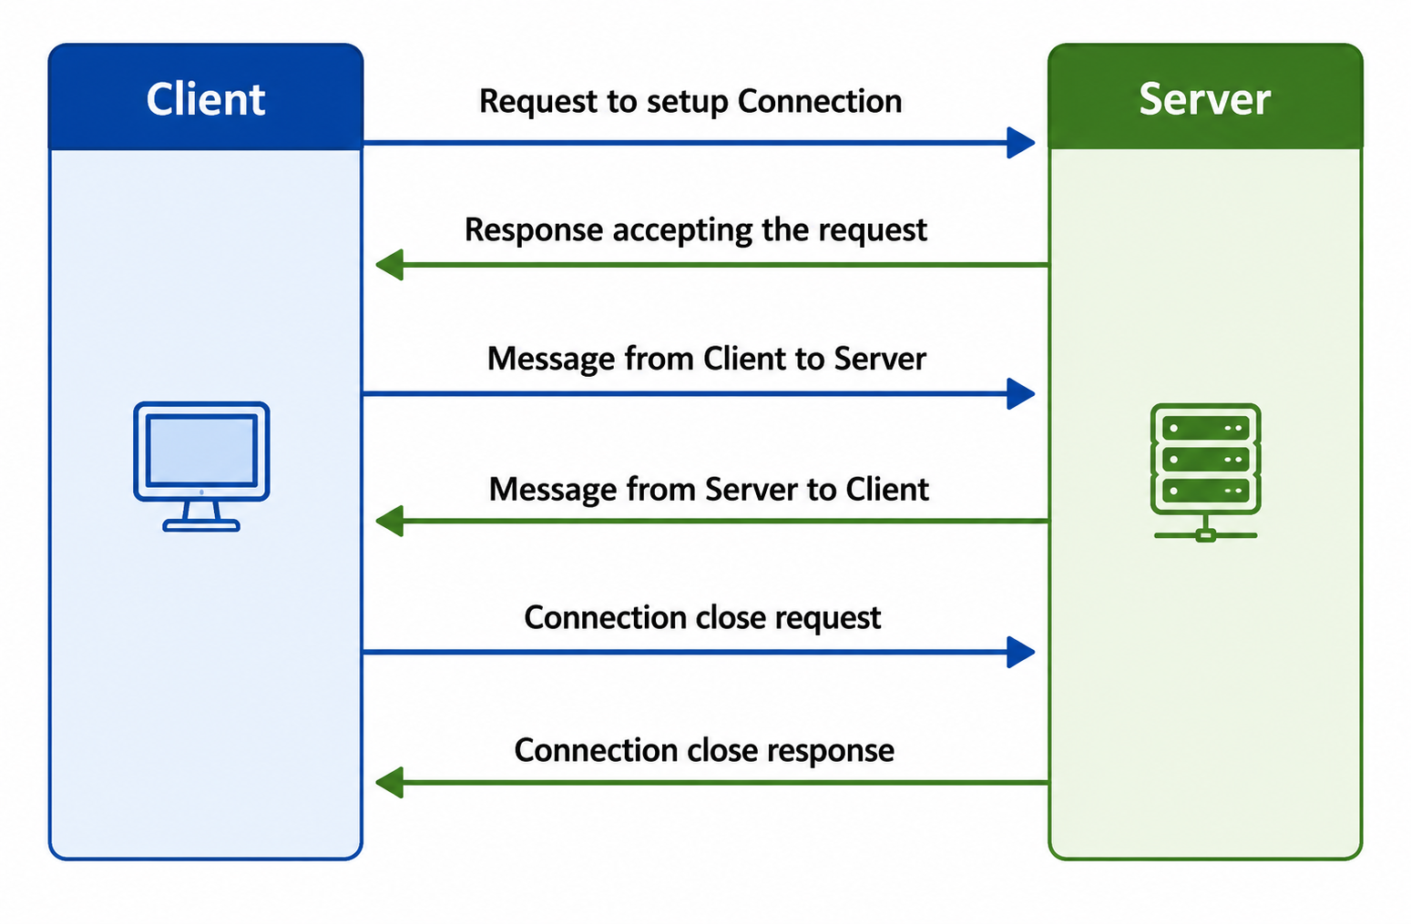
Figure 1.10: Exclusive Pair Communication Model

⭐ KEY POINT: Exclusive Pair = STATEFUL + FULL-DUPLEX + PERSISTENT. Best for real-time applications like live dashboards. WebSocket is its protocol.
Comparison of All Four Models

Model | Stateful? | Connection | Main Protocol | Best Application
Request-Response | No (stateless) | Per request | HTTP, CoAP | Data queries, standard REST APIs
Publish-Subscribe | No | Via broker | MQTT, AMQP | Sensor telemetry, notifications
Push-Pull | No | Via queue | ZeroMQ, Kafka | Data pipelines, batch analytics
Exclusive Pair | Yes (stateful) | Persistent | WebSocket | Live dashboards, real-time control

📝 EXAM TIP: "Explain all four IoT communication models" — guaranteed 9-mark question. For each model write: how it works (3 sentences) → protocol used → one real example → key property. Finish with the comparison table.
4.2 Communication APIs

▶ REST-Based APIs

📖 DEFINITION: REST (Representational State Transfer) — An architectural style for web services that uses standard HTTP methods to access and manipulate resources identified by URLs.
REST is built on six architectural constraints. The Client-Server constraint separates the user interface from data storage, allowing each to evolve independently. Statelessness requires every HTTP request to contain all the information needed to process it — the server never stores session state between requests. Cacheability allows responses to be cached by clients, reducing server load and improving performance. The Layered System constraint means a client cannot tell whether it is directly connected to the server or to an intermediate load balancer, allowing the system to scale transparently. The Uniform Interface constraint standardises how resources are accessed: every resource has a URI, and standard HTTP methods (GET, POST, PUT, DELETE) are used consistently. Code on Demand is an optional constraint that allows servers to send executable code to clients.
HTTP Method | Action | Example
GET | Retrieve a resource | GET /sensors/temp → returns temperature reading
POST | Create a new resource | POST /devices → registers a new device
PUT | Update an existing resource | PUT /sensors/1 → updates sensor settings
DELETE | Remove a resource | DELETE /devices/5 → removes device from system

▶ WebSocket-Based APIs

📖 DEFINITION: WebSocket — A communication protocol that provides a full-duplex, persistent TCP connection between client and server, allowing both sides to send messages at any time after a single handshake.
WebSocket follows the Exclusive Pair communication model. Once the initial HTTP handshake upgrades the connection to WebSocket, the connection stays open permanently until either side closes it. This makes WebSocket ideal for IoT applications that require continuous real-time data exchange, such as live power grid monitoring, industrial process control, and financial data feeds. Unlike REST, where the client must repeatedly send requests to get updates, a WebSocket-connected dashboard receives data automatically as soon as new sensor readings are available.
Feature | REST (HTTP) | WebSocket
Connection | New per request | Persistent, always open
State | Stateless | Stateful
Direction | Client initiates only | Full-duplex (both sides)
Latency | Higher (connection overhead) | Lower (no repeated setup)
Overhead | High HTTP headers per request | Minimal after handshake
Caching | Supported | Not supported
Best for | Data APIs, CRUD operations | Real-time dashboards, live feeds

📝 EXAM TIP: "Compare REST and WebSocket" — know the 6 REST constraints and the 7-row comparison table. This appears both as a standalone question and as part of a larger question on communication models.

TOPIC 5: IoT Enabling Technologies (Hour 5)

IoT as we know it today is built on five key enabling technologies. Without any one of these, the IoT ecosystem would not function at its current scale. Understanding these technologies helps you see how a small sensor in a field can ultimately result in an insight displayed on a smart city management dashboard.
5.1 Wireless Sensor Networks (WSN)

📖 DEFINITION: WSN — A self-organising network of distributed sensor nodes that wirelessly collect data about physical and environmental conditions and transmit it to a central point for analysis.
A WSN consists of end nodes, which sense and transmit data; routers, which relay data across the network; a coordinator, which collects data from all nodes and manages the network; and a gateway, which bridges the WSN to the broader Internet or cloud. The most powerful property of a WSN is its ability to self-organise: when a node fails or a new node joins the network, the WSN automatically reconfigures its routing paths without human intervention. ZigBee (IEEE 802.15.4) operating at 2.4 GHz with 250 Kb/s data rate and a range of 10–100 metres is the dominant WSN protocol. WSNs are used in weather monitoring across large geographic areas, indoor air quality measurement, soil moisture monitoring for precision agriculture, structural health monitoring of bridges and buildings, surveillance systems covering wide areas, and smart grid voltage and current monitoring.
⭐ KEY POINT: WSN superpower = SELF-ORGANISING. The network automatically fixes itself when nodes fail or new nodes join. This is what makes large-scale IoT deployments practical.
5.2 Cloud Computing

📖 DEFINITION: Cloud Computing — The delivery of computing resources — including processing power, storage, databases, networking, and software — over the Internet on a pay-per-use basis, without requiring the user to own or manage physical hardware.
Cloud computing solves a fundamental IoT problem: individual IoT devices have very limited processing power and storage capacity, yet they collectively generate enormous amounts of data that must be stored, analysed, and acted upon in real time. By offloading these tasks to cloud servers, IoT systems can scale from a handful of sensors to millions without any changes to the devices themselves. Cloud services are delivered in three models. Infrastructure as a Service (IaaS) provides virtual machines and raw storage — for example, AWS EC2 instances running IoT data processing code. Platform as a Service (PaaS) provides managed development platforms and APIs — for example, AWS IoT Core provides a managed MQTT broker that handles millions of device connections. Software as a Service (SaaS) provides complete application software accessed through a browser — for example, an online IoT monitoring dashboard.
🧠 TRICK: IaaS = Rent a computer. PaaS = Rent a workshop. SaaS = Rent a finished product ready to use.
5.3 Big Data Analytics

📖 DEFINITION: Big Data — Datasets so large in volume, fast in velocity, or varied in type that traditional database tools cannot store, manage, or analyse them effectively.
IoT is one of the biggest generators of Big Data in the world. A single wind farm with 500 turbines, each equipped with 100 sensors sampling every second, produces terabytes of data every day. A smart city with millions of sensors produces hundreds of gigabytes per hour. The three defining properties of Big Data are Volume (the sheer quantity of data, often in petabytes), Velocity (the speed at which data is generated and must be processed, often in real time), and Variety (the diversity of data formats — structured sensor readings, unstructured video, GPS coordinates, images, and text). Traditional relational SQL databases cannot handle this scale. Big Data frameworks such as Apache Hadoop (for batch processing of historical data) and Apache Spark (for real-time streaming analysis) are used instead.
⭐ KEY POINT: IoT + Big Data are inseparable. IoT generates the data; Big Data tools (Hadoop, Spark) make sense of it at scale.
5.4 Communication Protocols

Communication protocols are the backbone of the entire IoT ecosystem. Without standardised protocols, devices from different manufacturers could not communicate with each other. The protocols covered in Topic 2 — WiFi and ZigBee at the Link Layer; IPv6 and 6LoWPAN at the Network Layer; TCP and UDP at the Transport Layer; and MQTT, HTTP, CoAP, and WebSocket at the Application Layer — collectively form the communication infrastructure that allows a tiny sensor to send its readings all the way to a cloud database accessible from anywhere in the world.
5.5 Embedded Systems

📖 DEFINITION: Embedded System — A computer system with dedicated hardware and software designed to perform one or a small number of specific functions, usually as part of a larger system.
Almost every IoT device is at its heart an embedded system. Unlike general-purpose computers that can run any software, embedded systems are optimised for their specific task in terms of size, power consumption, and cost. A typical embedded system for IoT includes a microprocessor or microcontroller (such as the ARM Cortex-M or ESP32) that serves as the processing brain; memory components including RAM for temporary working storage, ROM or flash for permanent program storage, and cache for fast access; a networking unit providing WiFi or cellular connectivity; I/O units such as GPIO pins, ADC, and UART for connecting sensors and actuators; and specialised processors such as DSPs for signal processing tasks. Popular embedded platforms for IoT include the Raspberry Pi (Linux-capable), Arduino (simple C programming), NodeMCU (WiFi built in), and ESP32 (WiFi + Bluetooth + dual-core processor).
🔔 REMEMBER: Every IoT device IS an embedded system. It is purpose-built, power-efficient, and optimised for its specific sensing or actuation task.

TOPIC 6: IoT Levels & Deployment Templates (Level 1–6) (Hours 6–7)

Bahga and Madisetti define six levels of IoT system complexity based on three key factors: how many devices are in the system, where data analysis takes place (locally on the device or in the cloud), and where data is stored (locally or in the cloud). As the level increases, the system grows from a simple single-device setup to a large-scale distributed architecture with cloud intelligence and centralised control.
6.0 Standard Components of an IoT System

Before studying the levels, it helps to understand the standard building blocks that appear across all IoT deployments. A Device is the physical sensor or actuator node that interacts with the real world. A Resource is software running on the device that provides access to sensors and actuators, and stores local data. A Controller Service is a native software service on the device that communicates with the web service layer and receives remote commands. A Database stores IoT data — either locally on the device or in a cloud-hosted database. A Web Service (REST or WebSocket) bridges the device, the database, the analysis component, and the application. An Analysis Component processes the collected data — either through offline batch processing or real-time streaming. The Application is the user-facing interface through which humans monitor, visualise, and control the IoT system.
🔔 REMEMBER: REST Web Services store and retrieve data without maintaining a persistent connection. WebSocket Services maintain a live connection for real-time bidirectional communication.
Level 1 — Single Node, Everything Local

IoT Level 1 is the simplest possible deployment: a single device that performs all sensing, analysis, data storage, and application hosting locally, without involving any cloud services. The device connects directly to a local application through a REST or WebSocket service. All data is stored in a local database on the same device or in local storage. Level 1 is best suited for simple, low-complexity applications that do not generate large amounts of data. An example is a home automation system built on a single Raspberry Pi that controls lights and appliances and runs the monitoring application locally.
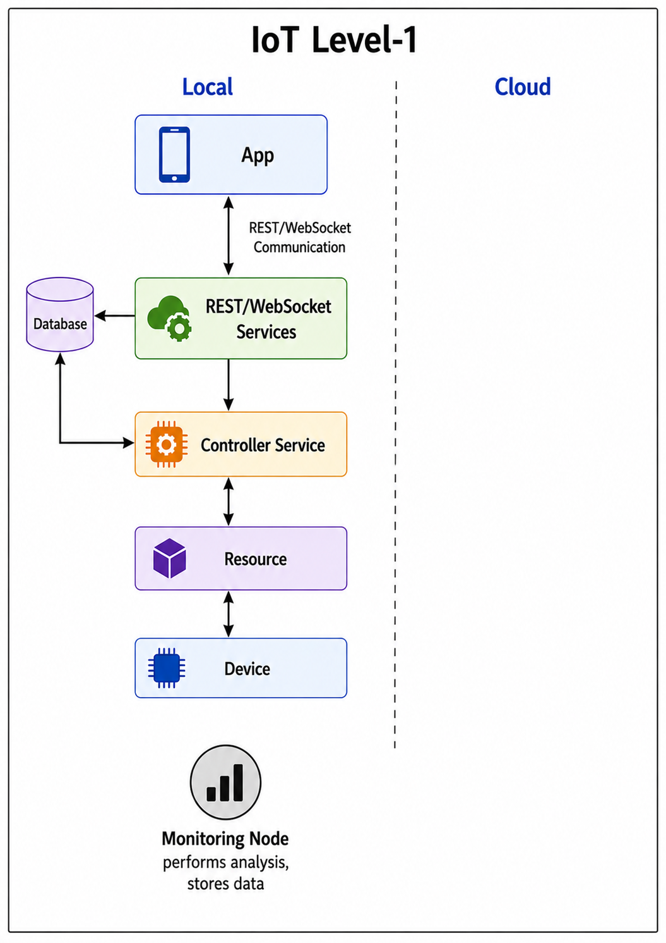
Figure 1.14: IoT Level-1 — Single Node, Local Analysis and Storage

Level 2 — Single Node, Cloud Storage

IoT Level 2 adds cloud storage to the Level 1 architecture while keeping data analysis local. A single device still performs all sensing and analysis, but the results are sent over the Internet to a cloud database for persistent storage. A cloud-hosted application can then retrieve and display this data from anywhere. This level is used when analysis is simple enough to run on the device but data volumes require scalable cloud storage. A smart irrigation system that analyses soil moisture locally and controls irrigation autonomously, but uploads all readings to a cloud database for long-term tracking, is a good example of Level 2.
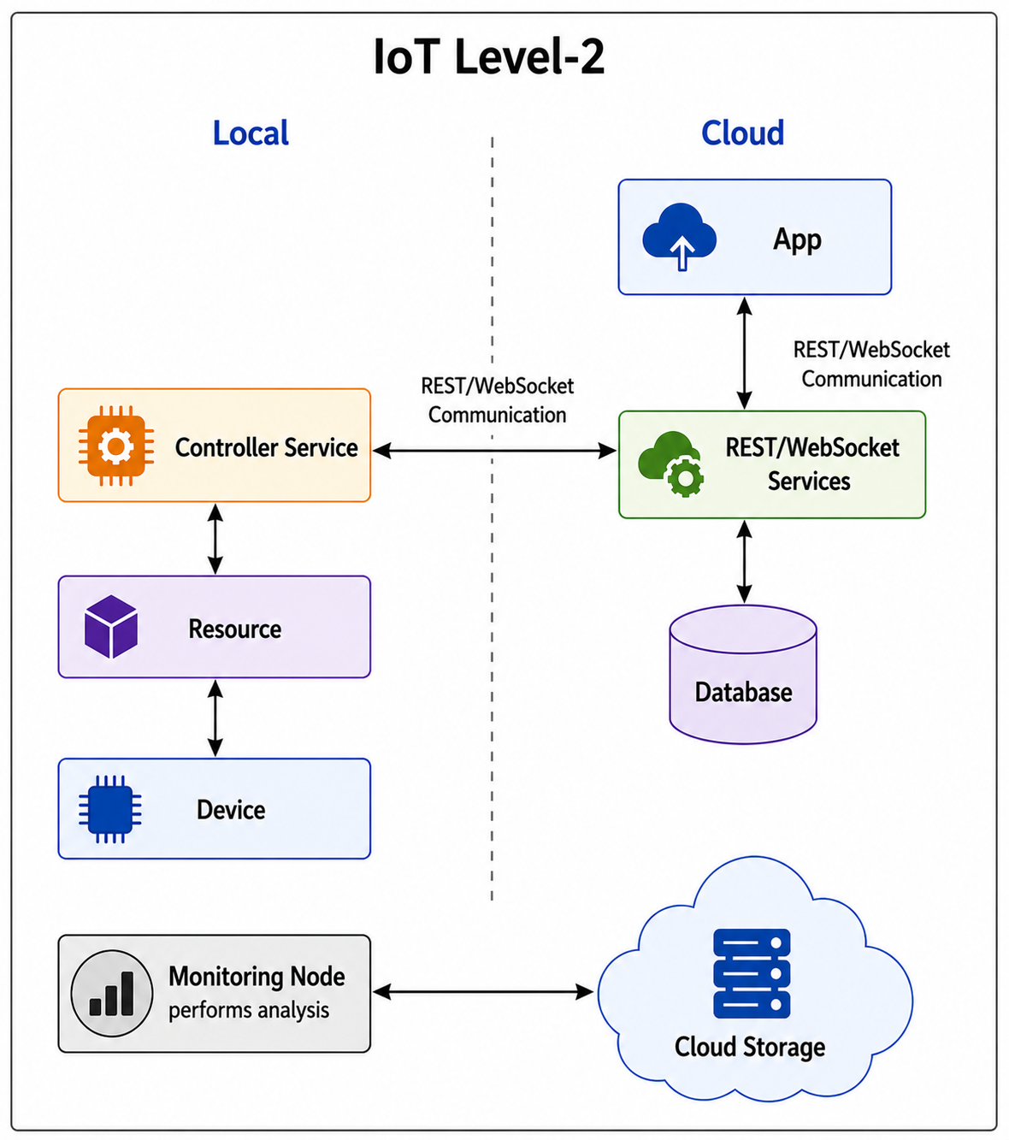
Figure 1.15: IoT Level-2 — Single Node, Local Analysis, Cloud Storage

Level 3 — Single Node, Cloud Analysis and Storage

In IoT Level 3, the device still has only a single node, but now both analysis and storage are moved entirely to the cloud. The device simply collects raw sensor data and uploads it to the cloud, where a more powerful cloud-based analysis component processes it and stores the results. This level is appropriate for data-intensive applications where the processing required is too heavy for the device itself. Package tracking systems that continuously upload accelerometer data to the cloud for vibration and shock analysis are a representative example.
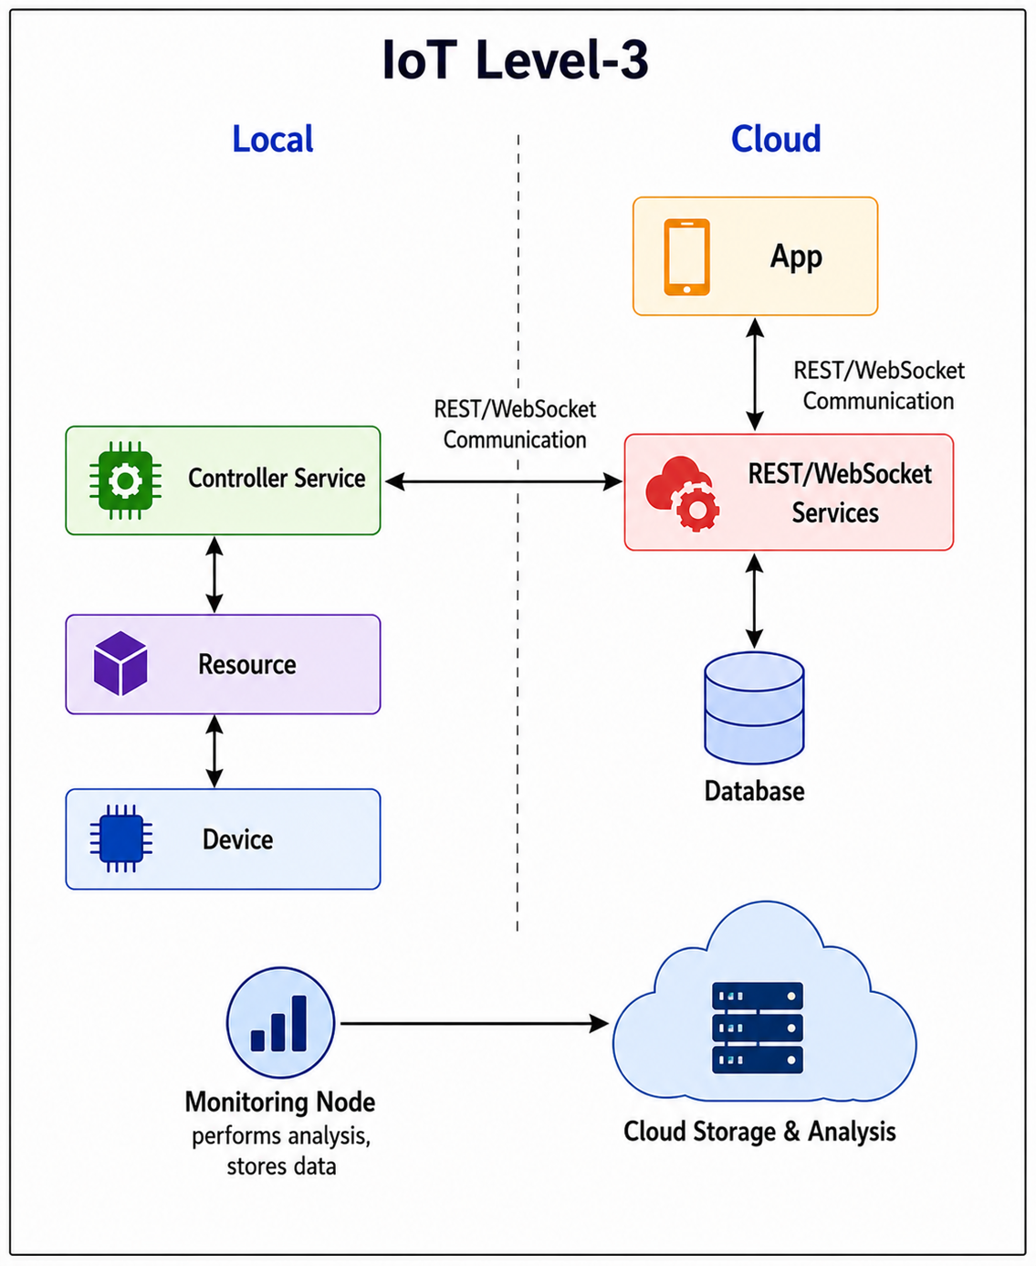
Figure 1.16: IoT Level-3 — Single Node, Cloud Analysis and Storage

Level 4 — Multiple Nodes with Observer

IoT Level 4 introduces multiple independent nodes, each capable of performing its own local analysis. A new type of node called an Observer Node is added to monitor all the other nodes — but crucially, the Observer Node only observes and reports; it does not control or command the other nodes. Data from all nodes is stored in the cloud. This architecture is used when multiple locations must be monitored independently, with a centralised observer tracking overall system health. A noise monitoring network deployed across a city, with multiple sensor nodes each analysing local sound levels and an observer tracking all readings, is a Level 4 system.
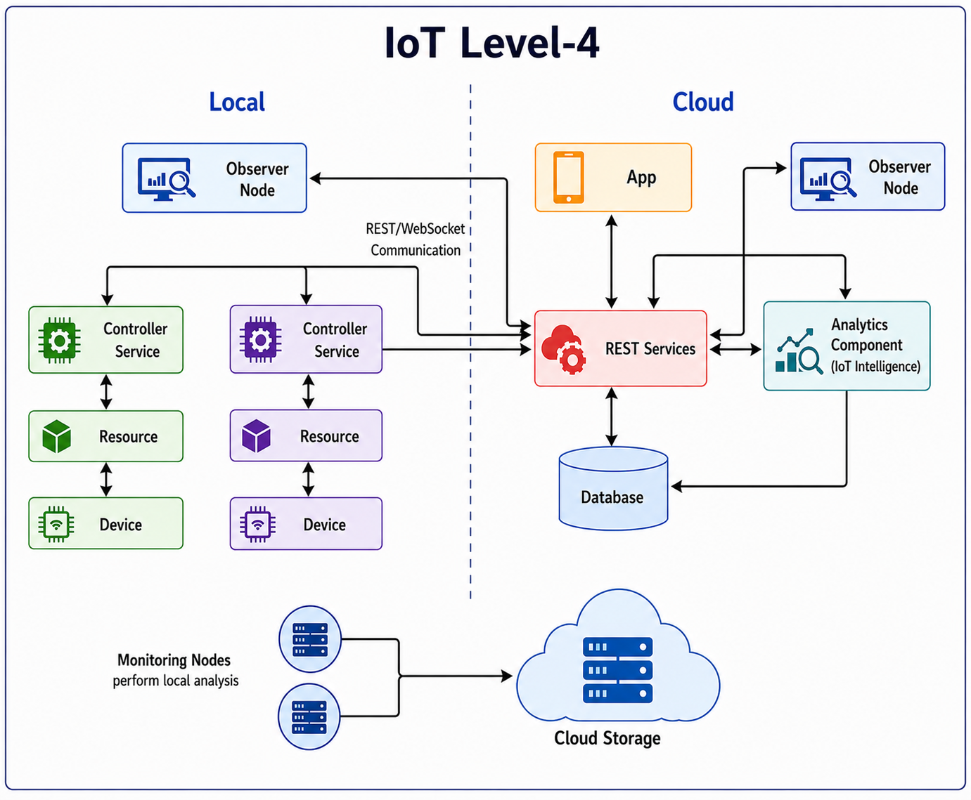
Figure 1.17: IoT Level-4 — Multiple Nodes with Observer

Level 5 — Multiple End Nodes with Coordinator

Level 5 introduces a Coordinator Node that collects data from multiple End Nodes and forwards it to the cloud. The end nodes are simple sensing devices — they collect data and send it to the coordinator over a short-range wireless network such as ZigBee. The coordinator aggregates all incoming data and sends it as a single stream to the cloud for storage and analysis. This is the classic Wireless Sensor Network architecture. An Observer Node monitors the overall system status. A forest fire detection system where dozens of sensor nodes spread across a forest measure temperature, humidity, and CO₂, and a coordinator collects all readings and sends them to a cloud monitoring service, exemplifies Level 5.
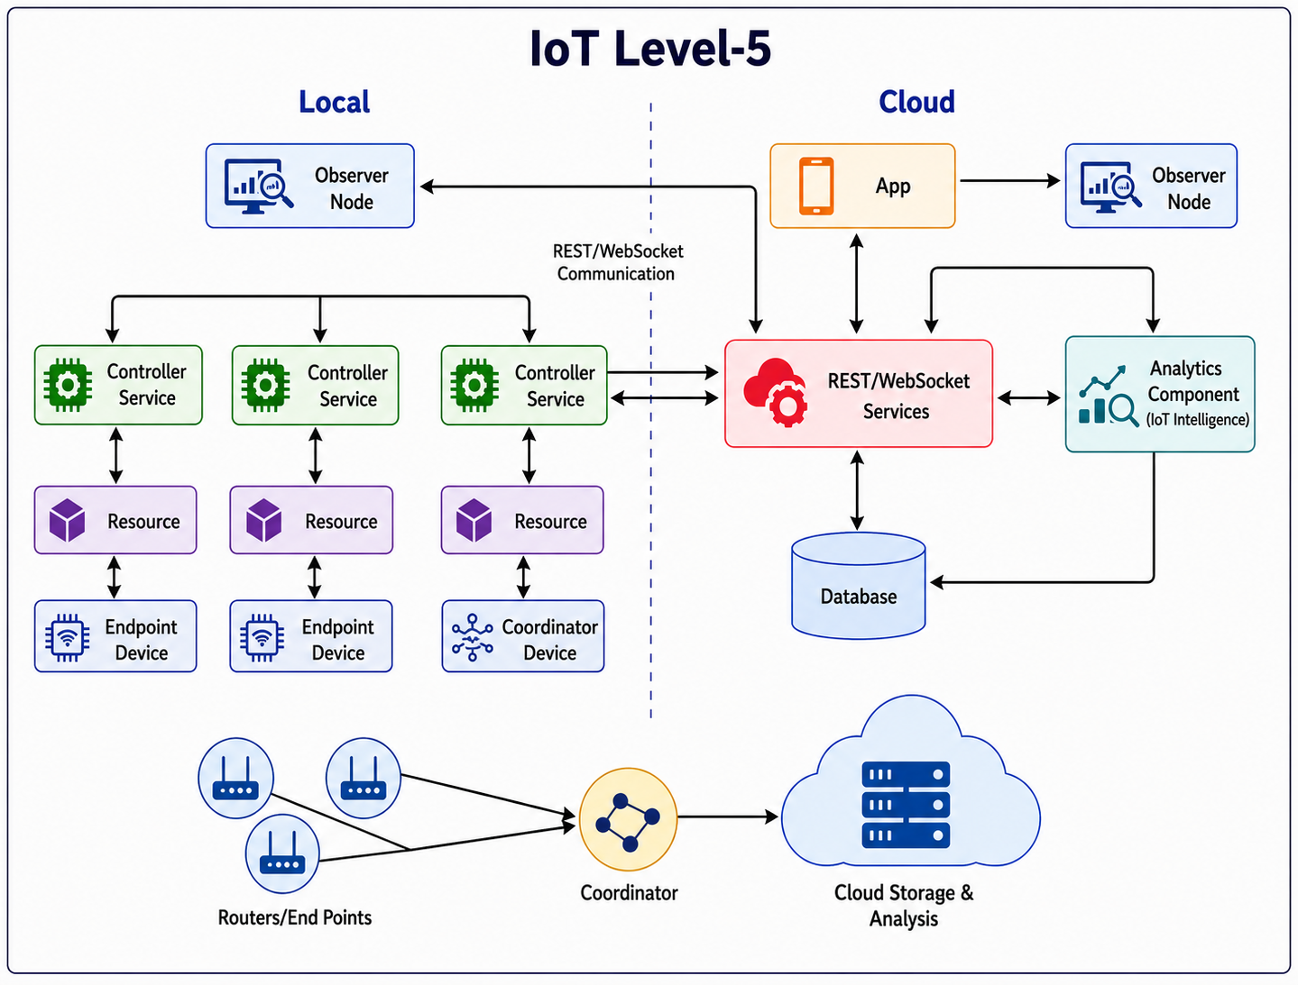
Figure 1.18: IoT Level-5 — Multiple Nodes with Coordinator

Level 6 — Multiple Nodes with Centralised Controller

Level 6 is the most complex IoT deployment. Multiple independent nodes each communicate directly with the cloud through their own REST or WebSocket services. A Centralized Controller — running in the cloud — receives all data from all nodes, runs advanced analysis and AI-driven intelligence, and issues coordinated commands back to all nodes simultaneously. An Analytics Component provides the intelligence layer. Observer Nodes monitor the system from both local and cloud perspectives. Level 6 is used for large-scale smart city and industrial automation systems. A weather monitoring network where hundreds of nodes across a country each upload their readings to the cloud, where a centralised controller aggregates the data, generates weather forecasts, and sends alerts to relevant nodes, is a typical Level 6 system.
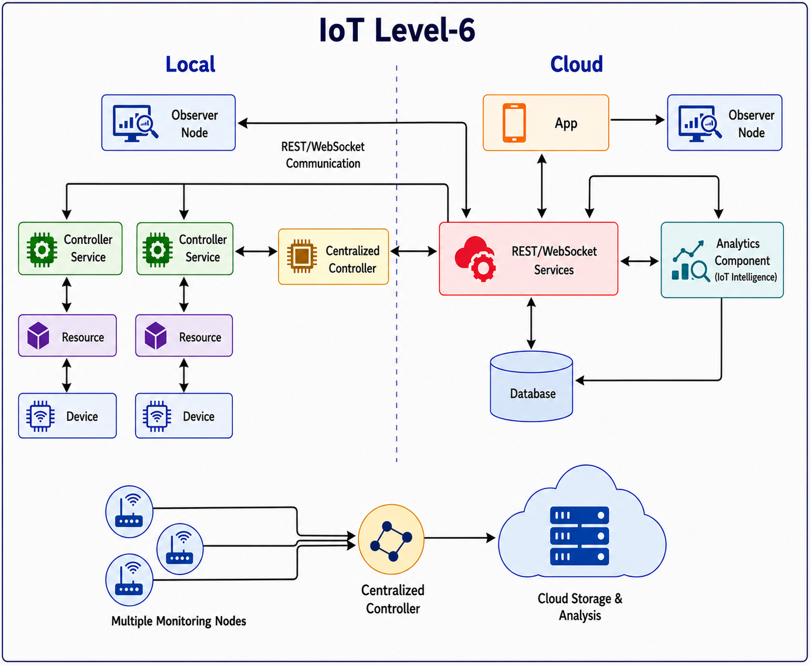
Figure 1.19: IoT Level-6 — Multiple Nodes with Centralised Controller

Quick Comparison of All Six Levels

Level | Nodes | Analysis | Storage | Key Feature | Example Application
1 | Single | Local | Local | No cloud — fully standalone | Home automation (Raspberry Pi)
2 | Single | Local | Cloud | Cloud backup of local analysis | Smart irrigation
3 | Single | Cloud | Cloud | Cloud does all heavy processing | Package vibration tracking
4 | Multiple | Local (each node) | Cloud | Observer monitors, does not control | City noise monitoring
5 | Multiple + Coordinator | Coordinator collects | Cloud | Classic WSN architecture | Forest fire detection
6 | Multiple (independent) | Cloud + AI analytics | Cloud | Centralized controller commands all | National weather network

🧠 TRICK: L4 = OBSERVER (watch, no control). L5 = COORDINATOR (collects from all end nodes). L6 = CENTRALIZED CONTROLLER (commands all nodes from cloud).
📝 EXAM TIP: "Explain IoT levels with examples" — a full 9-mark answer requires: for each of the 6 levels → number of nodes → where analysis happens → where data is stored → key distinguishing feature → one real example. The summary table above is worth memorising.

QUICK REVISION — Module 1 Key Definitions

Term | One-Line Definition
IoT | Network of uniquely identified, Internet-connected things that sense, communicate, and act.
Physical Design | Hardware devices + communication protocol stack of an IoT system.
Logical Design | Abstract view of what an IoT system does — 6 functional blocks.
WSN | Self-organising network of wireless sensor nodes; ZigBee/802.15.4 is its backbone.
Cloud Computing | On-demand Internet delivery of compute/storage on pay-per-use basis: IaaS/PaaS/SaaS.
Big Data | Data too large/fast/varied for traditional tools — Volume, Velocity, Variety.
Embedded System | Purpose-built computer hardware + software for a specific function.
MQTT | Lightweight publish-subscribe messaging over TCP. Most popular IoT protocol.
CoAP | HTTP-like protocol for constrained devices — runs over UDP.
6LoWPAN | IPv6 adaptation layer for 802.15.4 — enables IP addressing on tiny sensor nodes.
REST | Stateless HTTP-based API style using GET/POST/PUT/DELETE on resource URIs.
WebSocket | Full-duplex persistent TCP connection for real-time bidirectional communication.
Request-Response | Stateless — client asks, server answers; server forgets after each reply.
Publish-Subscribe | Decoupled — publishers send to topics via broker; subscribers receive automatically.
Push-Pull | Queue-buffered — producers push data in, consumers pull at their own pace.
Exclusive Pair | Persistent, full-duplex, stateful — both sides can send anytime (WebSocket).
IPv4 | 32-bit address = ~4.3 billion addresses (exhausted).
IPv6 | 128-bit address = 3.4×10³⁸ addresses (unlimited — essential for IoT).
IaaS | Infrastructure as a Service — rent virtual machines and storage.
PaaS | Platform as a Service — rent a managed development platform and APIs.
SaaS | Software as a Service — use complete software through a browser.
Observer Node | Monitors all nodes but does NOT control them (Level 4).
Coordinator Node | Collects data from all end nodes and forwards to cloud (Level 5).
Centralized Controller | Issues commands to ALL nodes from the cloud (Level 6).

EXAM QUESTIONS — Module 1

SECTION A — 3 Mark Questions

1. Define IoT. List and explain any FIVE characteristics of IoT. [L1 — CO1]
2. Describe the four layers of the IoT protocol stack with the protocols at each layer. [L2 — CO1]
3. Differentiate between IPv4 and IPv6. Why is IPv6 essential for IoT? [L4 — CO2]
4. What is MQTT? How does it differ from HTTP? Why is MQTT preferred for IoT devices? [L2 — CO2]
5. List the six functional blocks of an IoT system and state the role of any three. [L1 — CO2]
6. Compare TCP and UDP. Which is preferred for real-time IoT sensor streaming and why? [L4 — CO3]
7. What is the Publish-Subscribe model? Identify the three roles involved and the protocol used. [L2 — CO3]
8. Differentiate between IaaS, PaaS, and SaaS with one IoT example each. [L2 — CO3]
9. What are the three Vs of Big Data? Explain each with an IoT example. [L1 — CO3]
10. What is 6LoWPAN? What problem does it solve and how does it solve it? [L2 — CO2]
11. What is a Wireless Sensor Network? List its components and two IoT applications. [L1 — CO3]
12. Differentiate between REST and WebSocket APIs in any three points. [L4 — CO3]

SECTION B — 9 Mark Questions

Q1. Explain the Physical Design of IoT. Describe the IoT protocol stack with the protocols at each of the four layers, including examples and justification for their selection. [L2 — CO2]
✏ Answer structure: Intro: physical design = hardware + protocols → 4 layers table → Layer 1: Link (ZigBee, WiFi) → Layer 2: Network (IPv4 vs IPv6 vs 6LoWPAN) → Layer 3: Transport (TCP vs UDP) → Layer 4: Application (MQTT, CoAP, HTTP, WebSocket) → Conclusion.

Q2. Explain all four IoT communication models with diagrams. Include a comparison table. [L2 — CO3]
✏ Answer structure: For each model: how it works (3 sentences) → protocol used → one real example → key property → Then draw/describe the comparison table (Model, Stateful, Connection, Protocol, Best for) → Conclusion.

Q3. Describe the Logical Design of an IoT system. Explain all six functional blocks with their roles and sub-functions. [L2 — CO2]
✏ Answer structure: Intro: logical design = abstract view → List all 6 blocks → For each: role + sub-functions + example → Emphasise Security as cross-cutting concern → Draw functional block diagram.

Q4. Explain REST-based and WebSocket-based IoT Communication APIs. Include the six REST architectural constraints and a REST vs WebSocket comparison table. [L4 — CO3]
✏ Answer structure: REST definition → 6 constraints (one sentence each) → HTTP methods table → WebSocket definition → 7-row comparison table → When to use each → Conclusion.

Q5. Analyse the five IoT enabling technologies: WSN, Cloud Computing, Big Data Analytics, Communication Protocols, and Embedded Systems. Explain how they combine to enable modern IoT. [L4 — CO3]
✏ Answer structure: WSN: definition, components, self-organising, ZigBee, applications → Cloud: IaaS/PaaS/SaaS table → Big Data: 3 Vs with IoT examples, Hadoop vs Spark → Communication protocols: key ones at each layer → Embedded Systems: components, ESP32, Raspberry Pi → How they combine in an IoT pipeline.

Q6. Explain all six IoT levels and deployment templates with examples. Include a summary table and identify the key difference between each consecutive level. [L5 — CO1]
✏ Answer structure: For each level: nodes, analysis location, storage, key feature, one example → Summary table (6×5 columns) → Key progression: L1 standalone → L2 cloud storage → L3 cloud analysis → L4 observer added → L5 coordinator added → L6 centralized controller added.

End of Module 1 Student Study Notes | PEMRT525 | KTU S5 | JECC
Source: Bahga & Madisetti — "Internet of Things: A Hands-On Approach", Chapter 1

